Comprehensive Project Using Microsoft word, Excel and Power point

Presented By: Md.Sujon

Serial:11

Batch: 69

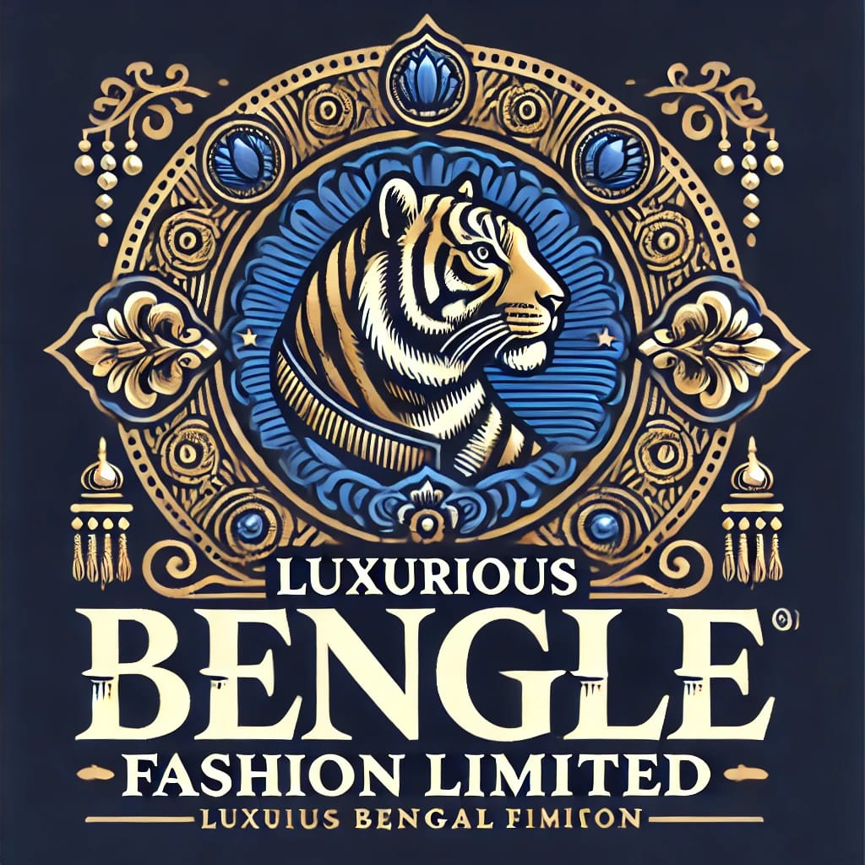

Table of Contents

1 Summary of luxurious Bengle Fashion limited 2

2 Key Areas of Focus 2

2.1 Product Range 2

2.2 Quality and Craftsmanship 2

2.3 Sustainability 2

2.4 Global Reach 2

2.5 Customer Experience: 3

3 Product and services 3

3.1 Apparel 3

3.2 Accessories 3

3.3 Footwear 3

3.4 Home Décor 3

3.5 Services of BFT 4

3.5.1 Personalized Styling 4

3.5.2 Custom Orders 4

3.5.3 Delivery and Fitting 4

3.5.4 Collaborations with Local Artisans 4

4 Business plan 5

5 Sales and Cost statistics 5

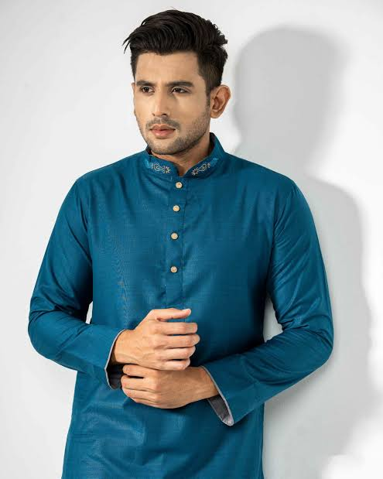 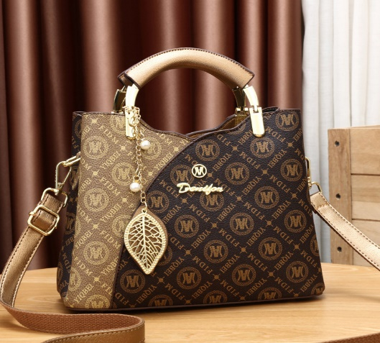  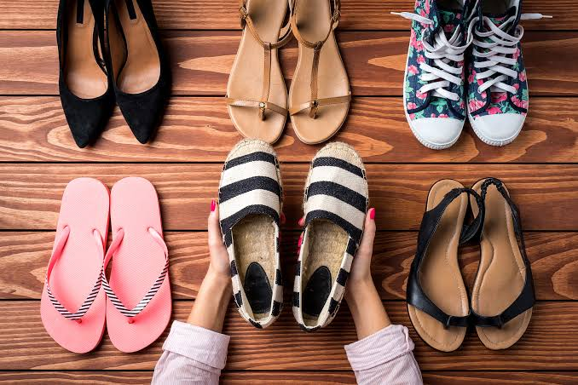

**luxurious Bengle Fashion Limited**

# Summary of luxurious bengle fashion Limited

Luxurious Bangle Ltd. is a prominent apparel and lifestyle company based in Bangladesh, known for its high-quality, innovative, and culturally inspired fashion products. Established in [2010], the company has made significant strides in the fashion industry by blending traditional Bangladeshi designs with modern global trends. The company's mission is to offer a wide variety of fashionable clothing while promoting local artisans and sustainable practices.

# Key Areas of Focus

## Product Range

Luxurious bengle Ltd. specializes in traditional attire such as sarees, kurtis, and panjabis, as well as contemporary apparel for both men and women. They also offer accessories like jewelry, handbags, and footwear.

## Quality and Craftsmanship

The company prides itself on its high-quality craftsmanship, sourcing premium fabrics and working with skilled artisans to create garments that are both stylish and durable.

## Sustainability

Sustainability is a core value, with the company using eco-friendly materials and ethical production processes. Banglaliana is committed to reducing its carbon footprint and ensuring that its manufacturing practices are socially responsible.

## Global Reach

While based in Bangladesh, luxurious Bengle Ltd. has expanded its reach globally, exporting to various countries and establishing a strong online presence. Their international shipping and personalized services cater to a wide range of global customers.

## Customer Experience:

The company emphasizes a personalized shopping experience both online and in-store, offering services like custom apparel design, fashion consultation, and bulk orders for special occasions.

With its dedication to quality, tradition, and innovation, luxurious Bengle Ltd. continues to grow as a leader in Bangladesh’s fashion industry, while maintaining a strong commitment to cultural heritage and modern fashion trends.

# Product and services

Luxurious Bengle Limited could focus on providing a unique blend of traditional and modern fashion, highlighting the rich cultural heritage of Bangladesh while integrating global trends. Its products may include:

## Apparel

Traditional garments such as sarees, salwar kameez, and Panjabis, combined with modern clothing like casual wear, formal wear, and fusion styles. The designs may incorporate intricate local embroidery, block printing, and other hand-crafted techniques.

## Accessories

Bangladeshi-inspired accessories, such as handcrafted jewelry, scarves, and bags, that showcase local artistry. These items could feature traditional elements like nakshi kantha (embroidered quilts) or jute-based accessories, an eco-friendly option.

## Footwear

Stylish footwear that blends cultural designs with modern comfort, such as handwoven sandals or eco-friendly jute shoes.

## Home Décor

Traditional home items like handwoven mats, cushions, and wall hangings, all made with local materials and techniques.

For more details please visit out website;

Luxurious bengle

## Services of BFT

### Personalized Styling

Services where customers receive styling advice tailored to their needs, combining modern fashion with traditional elements. This could be offered both online and in-store.

### Custom Orders

Offering customers the opportunity to design their own clothing or accessories based on traditional and contemporary styles.

### Delivery and Fitting

Fast delivery and fitting services that help customers find the perfect fit for their tailored garments.

### Collaborations with Local Artisans

By partnering with local artisans, the company could support and preserve traditional craftsmanship while providing exclusive collections that highlight unique craftsmanship.

These offerings could appeal to a wide range of customers who are passionate about local craftsmanship while desiring high-quality and fashionable products.

# Business plan

Bangaliana fashion limited as a global brand while retaining authentic charm of Bangladeshi heritage. To retain the success of this company we have follow above business plan:

Sustainable Initiatives

International expansion

# Sales and Cost statistics

|  |  |  |  |  |  |  |
| --- | --- | --- | --- | --- | --- | --- |
| Year | Total sales | Production cost | Marketing cost | Logistics and Overheads | Total cost | Profit |
| 2005 | 10,000,000 | 5,000,000 | 2,000,000 | 8,500,000 | 8,500,000 | 15% |
| 2006 | 11,500,000 | 5,750,000 | 2,300,000 | 9,775,000 | 9,775,000 | 15% |
| 2007 | 13,500,000 | 6,612,500 | 2,645,000 | 11,257,500 | 11,257,500 | 18% |
| 2008 | 20,159,000 | 7,579,500 | 3,000,000 | 12,879,500 | 12,879,500 | 20% |
| 2009 | 21,397,000 | 8,698,500 | 3,500,000 | 14,898,500 | 14,898,500 | 21% |